

**REPUBLIC OF GHANA**

**COMPOSITE BUDGET**

**FOR 2022-2025**

**PROGRAMME BASED BUDGET ESTIMATES**

**FOR 2022**

**GA EAST MUNICIPAL ASSEMBLY**

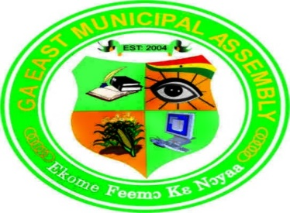

**APPROVAL STATEMENT**

The Ga East Municipal Assembly at its General Assembly Meeting held on the 28th of October, 2021 at the Ga East Municipal Assembly Conference Room passed a resolution to approve the 2022 Composite Budget as follows:

Compensation of Employees Goods and Services Capital Expenditure

**GH¢ 6,986,743.00** **GH¢ 8,788,524.00**  **GH¢ 11,191,743.00**

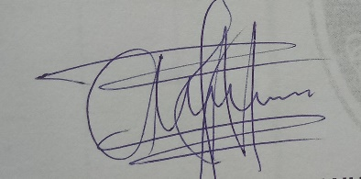Total Budget **GH¢ 26,967,010.00**



**Hon. Jesse Nii Noi Anum Vera Akuffo-Mante (Mrs)**

**(Presiding Member) (Co-ordinating Director)**

Table of Contents

**PART A: STRATEGIC OVERVIEW OF THE ASSEMBLY 1**

**Establishment of the District 1**

**Population Structure 1**

**Vision 2**

**Mission 2**

**Goals 2**

**Core Functions 2**

**District Economy 3**

**Key Issues/Challenges 6**

**Key Achievements in 2021 6**

**Revenue and Expenditure Performance 11**

**Adopted National Medium Term Development Policy Framework (NMTDPF) Policy Objectives 15**

**Policy Outcome Indicators and Targets 16**

**Revenue Mobilization Strategies 19**

**PART B: BUDGET PROGRAMME/SUB-PROGRAMME SUMMARY 20**

**PROGRAMME 1: MANAGEMENT AND ADMINISTRATION 20**

**PROGRAMME 2: SOCIAL SERVICES DELIVERY 36**

**PROGRAMME 3: INFRASTRUCTURE DELIVERY AND MANAGEMENT 48**

**PROGRAMME 4: ECONOMIC DEVELOPMENT 48**

**PROGRAMME 5: ENVIRONMENTAL MANAGEMENT 48**

**PART C: FINANCIAL INFORMATION 48**

# **PART A: STRATEGIC OVERVIEW OF THE ASSEMBLY**

## **Establishment of the District**

The Ga East Municipal Assembly was carved out of the then Ga District and was established in 2004 by an Act of Parliament (LI1589) as a district. Later in 2008 it was elevated to a municipality status by LI 1864. The Municipality was again divided in 2012 giving birth to La Nkwantanang, Madina Municipal.

The General Assembly is represented by Ten (10) elected members, Five (5) Government appointees and one (1) Member of Parliament. The Assembly has two (2) local Zonal Councils namely Abokobi and Dome Zonal Council with 25 Unit Committee members in each.

The Ga East Municipal Assembly is located at the northern part of the Greater Accra Region and covers a land area of about 96 sq km. The Assembly is boarded on the west by the Ga West Municipal Assembly (GWMA), on the east by La Nkwatanang-Madina Municipal Assembly (LaNMA), on the South by Ayawaso West Municipal Assembly and on the North by the Akwapim South District Assembly- Aburi in the Eastern region. The capital town is approximately 29 kilometers from the country’s capital city, Accra. Some of the notable towns in the municipality includes, Abokobi, Agbogba, Haatso, Papao, Westlands, Dome, Taifa, Kwabenya, Ashongman, Ablor-Adjei and Dome Pillar 2. Other areas are Boi, Sesemi, Adenkrebi, Kponkpo, Adjako and part of Teiman.

## **Population Structure**

According to the 2021 Population and Housing Census the Municipality has an estimated population of 283,379 persons. The population structure of the district can be described as a youthful population with more than half under the age of 24 years. The sex structure is estimated as 143,364 ( 50.6% ) being females and 140,015 (49.4%) males. This gives the sex ratio of 1:1.04 males to females. The dominance of females over males is a reflection of the nationwide trend where the estimated ratio is 1:1.03. The need to target women in any development programme in the Municipality can therefore not be overemphasized.

The district has about 52 settlements with not less than 80% of the population living in the urban areas and the remaining 20% occupies the rural areas.

## **Vision**

To become a highly professional socio-economic service provider that creates opportunities for human resource development in partnership with stakeholders.

## **Mission**

To facilitate improvement in quality of life of the people in the Municipality through the provision of basic social service and the promotion of socio-economic development within the context of the governance.

## **Goal**

The goal of the Assembly is to achieve sustained, accelerated and inclusive socio-economic growth and poverty reduction towards improvement in the quality of life of the people.

## **Core Functions**

The core functions of the Ga East Municipal Assembly are outlined below:

* Exercise political powers and administrative authority, provide guidance, give direction to, and supervise other administrative authorities in the Municipality.
* Responsible for the overall development of the Municipality and ensure the preparation and submission of development plan and budget through RCC for approval by MoF.
* Formulate and execute plans, programmes and strategies for the effective mobilization of the resources necessary for the overall development of the Municipality.
* Promote and support productive activity and social development in the municipality
* Initiate programs for the development of basic infrastructure and provide municipal works and services in the municipality
* Responsible for the development, improvement and management of human settlement and the environment in the municipality
* Shall ensure the ready access to courts in the municipality for the promotion of Justice.

## **District Economy**

* **Agriculture**

Farming is the major economic activity for about 55% of the economically active population. About 70% of the rural population depends on agriculture as their main source of livelihood with about 95% of them being small holders. The major agricultural activities are crop production, poultry and livestock production. Among the wide range of vegetables produced are pepper, tomatoes, cabbage, okra and garden eggs. Livestock production has a very good potential and the district is encouraging it. There are a number of poultry farmers in and around Abokobi, the Municipal capital. The major one is the Abokobi Agriculture Project; with the current Agriculture Programme the Municipality is poised for a greater achievement under Agriculture.

* **Road Network**

Road is the only form of transport in the district. This implies that, the overall improvement of the road network, maintenance and rehabilitation will facilitate and lower transportation cost and integrates the Municipality’s rural economy with the urban economy to reduce poverty. In general, the road network in the district can be described as not too good but the Assembly embarks on routine maintenance of the roads with the help of the Assembly grader.

* **Health**

The Ga East Municipal Health Management Team (MHMT) is responsible for all health service delivery in the entire municipality. The municipality is divided into four sub municipals for the organization and distribution of primary health care services. These sub municipals are namely Abokobi, Dome, Taifa and Haatso. Each sub municipal health management team has the responsibility for the delivery of health services to defined areas, population and has a centre with either one or two community clinics. There are trained TBAs and other care providers such as chemical shop dealers, maternity homes, traditional healers, etc in the municipality.

The Doctor-Patient Ratio stands at 1:167,715 with 1 doctor while the Nurse-Patient Ratio is 1:759, with 221 nurses. There are also 46 midwives currently serving in the municipality.

There are twenty health facilities in the municipality; this is made-up of 1 District Hospital, 1 Polyclinic, 2 Quasi Government and 16 Private Health Centres. There are fourteen (14) CHPs Zones currently in the municipality with 1 CHPs compound.

* **Education**

Educational infrastructure is evenly distributed in the municipality. Locations of schools are within easy reach of all children located in various parts of the municipality. There are 276 schools at the Primary education level made up of 32 public schools and 244 private schools. The total number of Junior High Schools sum up to 165, with 32 being public and 133 being privately owned. There are four (4) privately owned Secondary Schools, the only public Senior High School is the Kwabenya Community Senior High School which was established in 2016. The total number of Early Childhood Centres (ECDC) stands at 274. This is made up of 244 private and 30 public.

The Pupil Teacher Ratio (PTR) for KG is 1:34 that for primary is 1:37, while that of JHS is 1:21. At the SHS level, Student Teacher Ratio is 1:25. The PTRs for KG and Primary are higher than the national target of 25 and 35 for KG and primary respectively; this implies that municipality needs more teachers at these levels.

* **Market Centres**

The major marketing centres within the district are the Atomic-Kwabenya Market, Dome Market, Taifa Market, Taifa-Burkina Market, Haatso market, Abokobi market, etc.

* **Water and Sanitation**

Potable water supply in the urban/peri-urban areas of the municipality has been a major challenge to the Assembly, especially when the Assembly has no direct control over urban water supply. Areas like Dome, Taifa, Agbogba, Musuko and Ashongman have limited or no access to pipe-borne water. Others depend on tanker services and a few hand dug wells.

The Assembly is currently managing two small towns; piped schemes through Water and Sanitation Development Boards (WSDD). These are Abokobi-Oyarifa-Teiman Area Scheme, and Pantang Area Water Scheme. The water and sanitation coverage in the municipality is given below:

* % of household with private toilet – 32%
* % of population using public toilet -37%
* % of population with access to potable water – 42%

Sanitation and Hygiene is a major concern for the Municipality with major issues relating to public health, such as the provision of household and institutional toilets, clean drinking water, adequate sewage disposal and final disposal of refuse.

Some of the sanitation challenges in the municipality are noise nuisance, dumping of refuse at unauthorized sites, Houses without household toilets, inappropriate disposal of sullage and the menace of plastic waste.

Sanitation Clubs has been inaugurated in Thirty-One (31) schools in the municipality, with the main purpose to instill and inculcate in the children the practice of waste segregation in the schools and their various homes.

* **Tourism**

Though the development of tourism has numerous benefits to society, the Assembly is however yet to tap into its existing tourism potential which include; the slave site at Kponkpo and Frederiksgave Plantation and Common Heritage site at Sesemi.

## **Key Issues/Challenges**

* Poor road Network
* Inadequate Public Health Facilities in the municipality
* Encroachment on school lands
* Lack of disposal site
* Perennial Flooding

## **Key Achievements in 2021**

* Constructed Fence Walls around Kwabenya Cluster Schools, Atomic Hills Cluster schools and Ashongman Presbyterian Basic School
* Reshaped and gravelled Abokobi, Ashongman, Purewater and Cosway roads
* Donated items to the Ga East Municipal Hospital to support the fight against COVID-19
* Sensitized 300 Public and Private Schools within the Municipality on compliance on COVID- 19 protocols
* Established Enterprise Savings and Loans Scheme with support from USAID and Ghana Poultry Project to facilitate credit accessibility by farmers and to develop the culture of savings among farmers.
* Mobilized and facilitated the Needle for Girls project an initiative of the Office of the Second Lady
* Distributed 200 piglets to 40 Farmers as support for rearing for food and jobs
* Development of GEMA App for payment of property rates
* Completed the construction of a 3-storey Modified Assembly Hall and Storage block
* Exempted Private Educational Institutions from the payment of Business Operating Permit (BOP) for 2020 as covid relief package
* Immunized 1000 children against childhood killer diseases
* Donated items to 11 persons with disability (PWDs)
* Screened 2,613 food vendors to promote public health hygiene
* Planted 7,000 trees to improve climate change adaptation measures

**DONATION OF ITEMS TO THE GA EAST MUNICIPAL HOSPITAL**

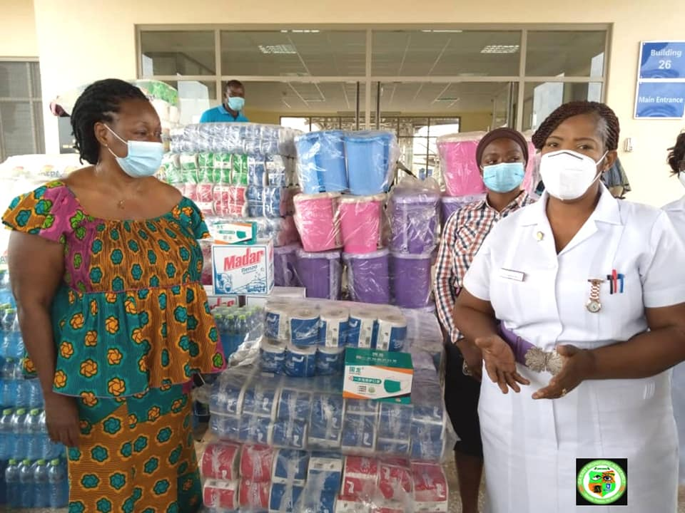

**CONSTRUCTION OF DIVISIONAL FENCE WALL AROUND THE ASHONGMAN PRESBYTERIAN BASIC SCHOOL**

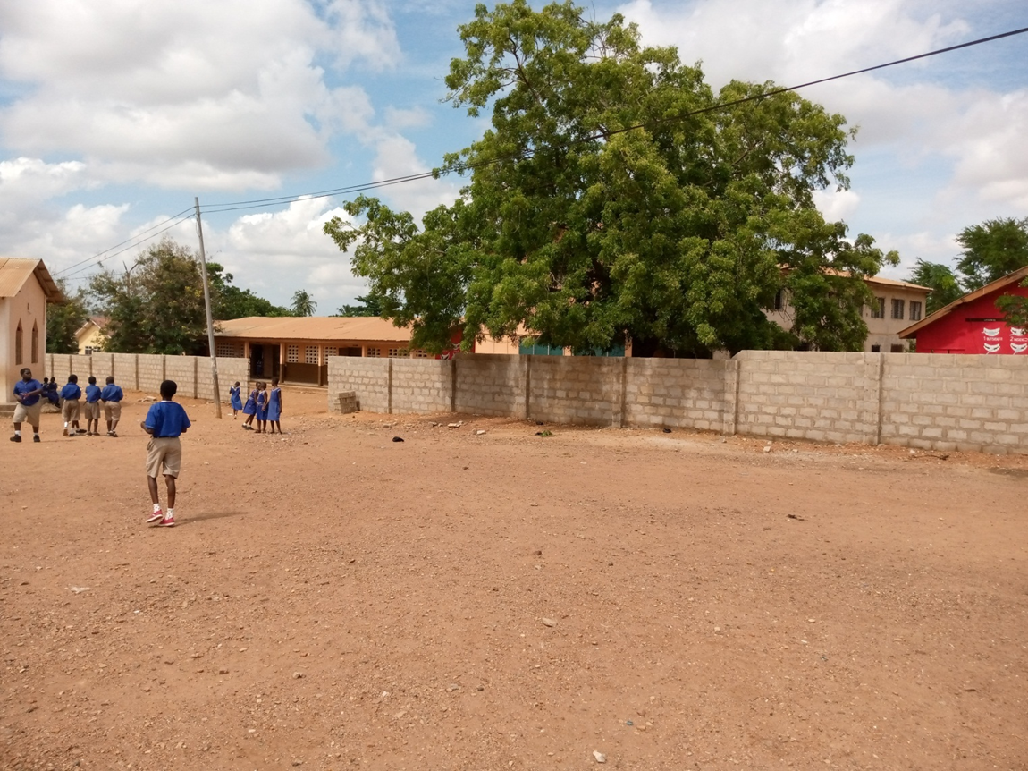

**COMPLETION OF 3-STOREY MODIFIED ASSEMBLY HALL AND STORAGE BLOCK**

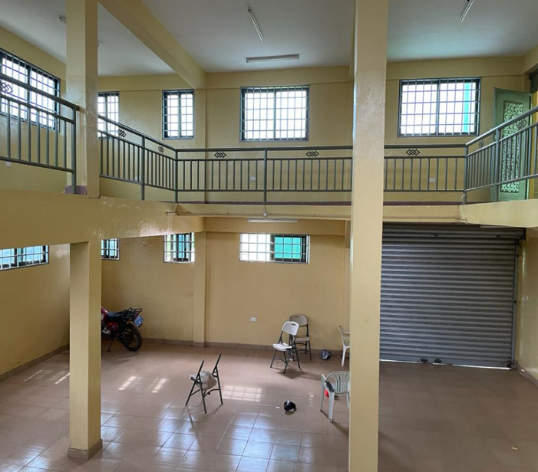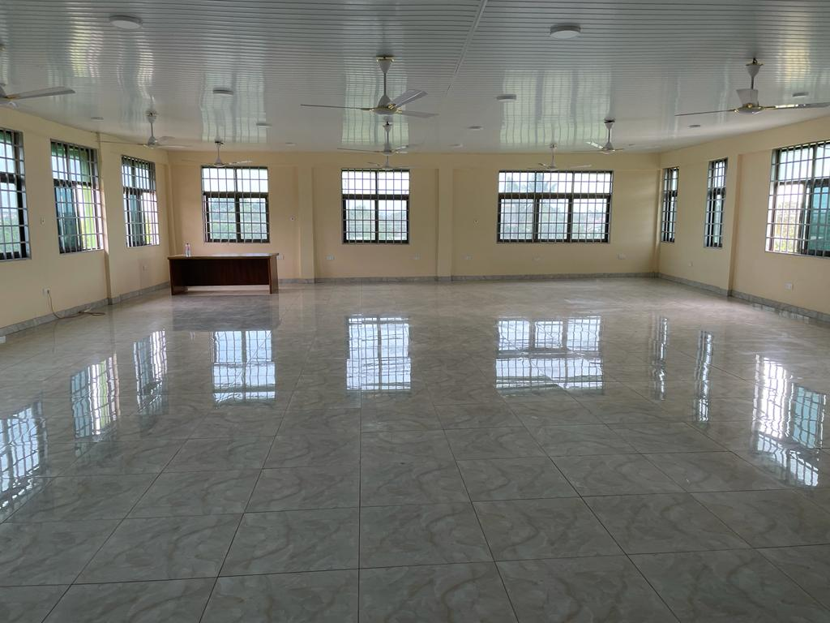

**RE-SHAPING AND SPOT IMPROVEMENT OF ASHONGMAN PURE WATER ROAD (GOLD AVENUE RD)**

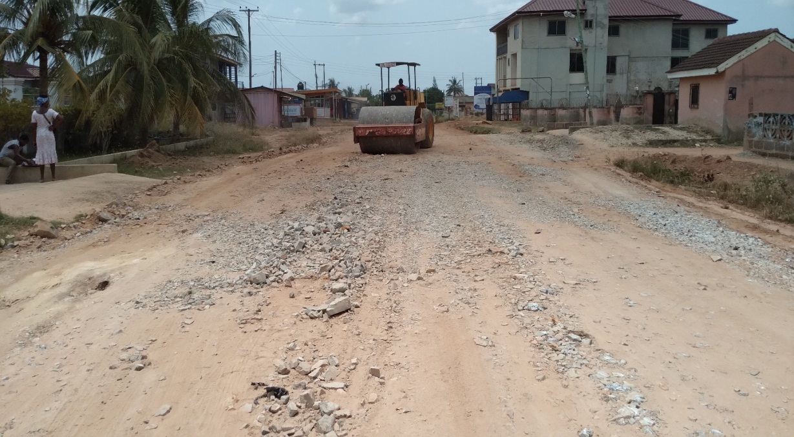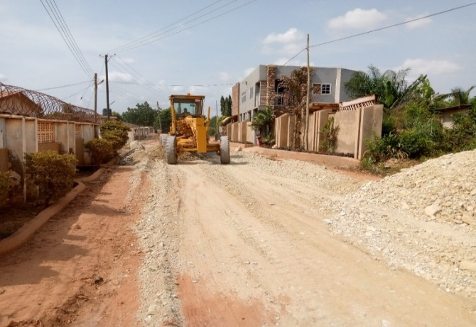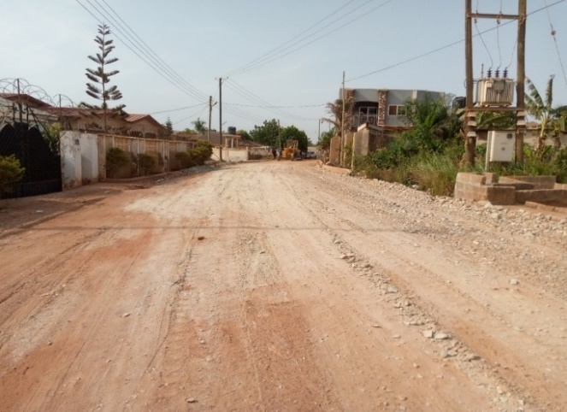

**GRAVELLING OF ABOKOBI TOWN ROADS**

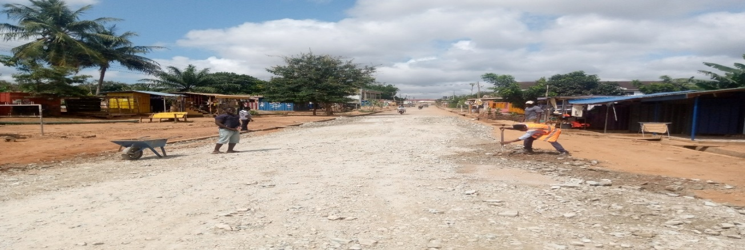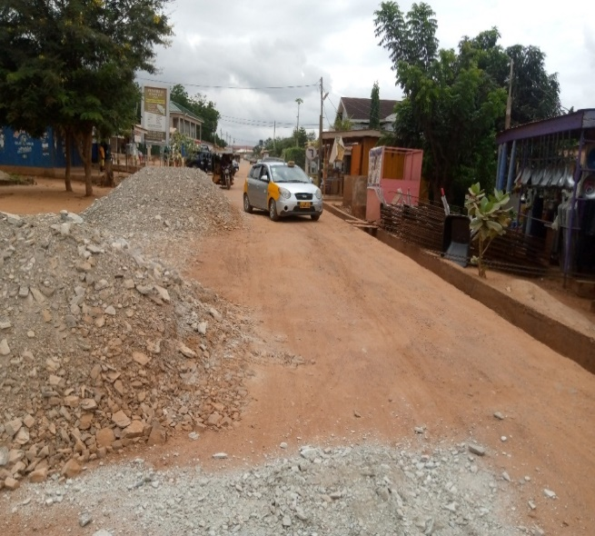 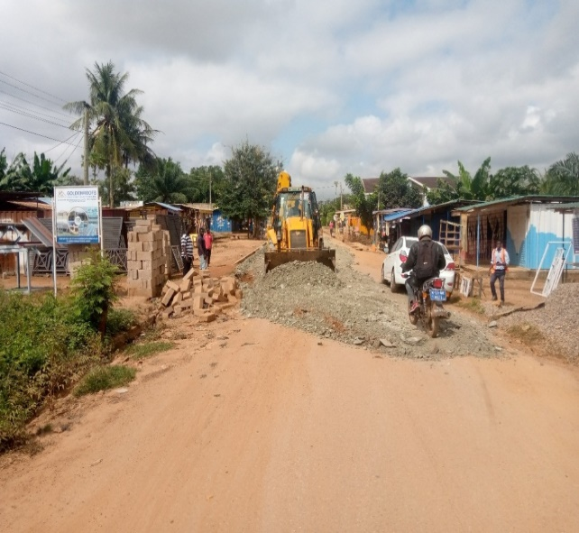

## **Revenue and Expenditure Performance**

Trend analysis of internally generated funds has showed an improvement in collection. The target for 2019 was exceeded by 14.06% and a percentage performance of 97.96% was recorded in 2020. As at July 2021, an amount of GHȻ 4,990,363.39 has been mobilized, representing 60.48 percentage points. See Table 1. In addition, revenue item like Land (Building permits) contributed the highest (37.16%) to total IGF as at July 2021 , this is followed by property rates (34.75%) , licenses (20.06%) , fees (7.63%) , rent (0.25%) and fines (0.15%).

The total revenue performance of the assembly has also been remarkable, with 2019 recording an amount of GHȻ 13,446,819.98 against a target of GHȻ 18,446,338.61. Revenue performance for 2020 stood at 81.29 percent of the target amount of GHȻ 18,446,338.61 as indicated in Table 2 . As at July 2021, an amount of GHȻ 10,0302,215.73 has been mobilized against the estimated amount of GHȻ 21,149,717.67.

Expenditure on capital and infrastructural projects has improved with increased commitment from GHȻ 2,399,964.18 in 2019 to GHȻ 4,352,424.00. An amount of GHȻ 1,168,029.20 has been spent as at July 2021, this is mainly due to delay in the release of the District Assemblies’ Common Fund to undertake projects earmarked for the current year. Clearly from the table 3 below, the focus of the assembly has been shifted to the provision of more public goods.

**Revenue**

**Table 1: Revenue Performance – IGF Only**

|  |  |  |  |  |  |  |  |
| --- | --- | --- | --- | --- | --- | --- | --- |
| **ITEM** | **2019** | | **2020** | | **2021** | | **% performance as at July** |
| **Budget** | **Actual** | **Budget** | **Actual** | **Budget** | **Actual as at July 2021** |
| Property Rate | 1,386,420.00 | 1,105,022.14 | 1,759,980.00 | 2,087,563.73 | 2,643,174.42 | 1,734,192.90 | **34.75** |
| Fees | 368,781.00 | 455,884.82 | 686,320.00 | 663,086.83 | 697,040.00 | 380,768.24 | **7.63** |
| Fines | 17,400.00 | 15,837.00 | 39,900.00 | 24,054.00 | 25,800.00 | 7,300.00 | **0.15** |
| Licenses | 1,121,273.00 | 1,872,655.93 | 1,707,560.00 | 1,074,686.89 | 1,664,692.00 | 1,001,128.00 | **20.06** |
| Land | 2,278,240.00 | 2,401,392.47 | 2,483,860.00 | 2,726,707.91 | 3,170,330.58 | 1,854,284.25 | **37.16** |
| Rent | 49,520.00 | 105,060.00 | 85,000.00 | 48,410.00 | 49,800.00 | 12,690.00 | **0.25** |
| **TOTAL** | **5,221,634.00** | **5,955,852.36** | **6,762,620.00** | **6,624,509.36** | **8,250,837.00** | **4,990,363.39** | **100.00** |

**Table 2: Revenue Performance – All Revenue Sources**

|  |  |  |  |  |  |  |  |
| --- | --- | --- | --- | --- | --- | --- | --- |
| **ITEM** | **2019** | | **2020** | | **2021** | | **% performance as at July** |
| **Budget** | **Actual** | **Budget** | **Actual** | **Budget** | **Actual as at July** |
| IGF | 5,221,634.00 | 5,955,852.36 | 6,762,620.00 | 6,624,509.36 | 8,250,837.00 | 4,990,363.39 | **49.74** |
| Compensation Transfer | 4,453,430.30 | 3,875,144.26 | 4,538,264.72 | 4,471,310.52 | 4,719,795.31 | 2,599,973.39 | **25.91** |
| Goods and Services Transfer | 264,370.18 | 115,793.02 | 147,157.27 | 135,443.41 | 154,746.39 | 104,018.68 | **1.04** |
| Assets Transfer | 163,561.50 | - | - | - | - | - | - |
| DACF | 6,386,354.23 | 2,295,296.71 | 5,972,134.31 | 3,320,366.04 | 5,989,172.46 | 559,447.27 | **5.58** |
| DACF-RFG | 698,502.00 | 1,068,351.54 | 947,744.38 | 692,663.38 | 1,705,772.00 | 1,701,913.00 | **16.96** |
| GAMA | 1,135,486.40 | - | 315,486.40 | 20,000.00 | - | - | - |
| MAG | 123,000.00 | 136,382.09 | 123,402.98 | 105,365.12 | 80,707.00 | 37,500.00 | **0.37** |
| UNICEF | - | - | - | - | 70,000.00 | 40,000.00 | **0.40** |
| GASSLIP | - | - | - | - | 50,000.00 | 0 | **0.00** |
| GIZ | - | - | 100,000.00 | 0 | 128,687.51 | 0 | **0.00** |
| **Total** | **18,446,338.61** | **13,446,819.98** | **18,906,810.06** | **15,369,657.83** | **21,149,717.67** | **10,033,215.73** | **100.00** |

**Table 3: Expenditure Performance-All Sources**

|  |  |  |  |  |  |  |  |
| --- | --- | --- | --- | --- | --- | --- | --- |
| **Expenditure** | **2019** | | **2020** | | **2021** | | |
| **Budget** | **Actual** | **Budget** | **Actual** | **Budget** | **Actual as at July** | **% age Performance as at July** |
| Compensation | 6,034,715.30 | 5,255,229.63 | 6,072,287.56 | 5,939,209.07 | 6,475,960.30 | 3,501,281.47 | 47.29 |
| Goods and Services | 6,988,081.59 | 5,783,271.18 | 7,251,162.35 | 4,989,988.19 | 7,037,239.55 | 2,734,580.10 | 36.93 |
| Assets | 5,421,542.02 | 2,399,964.18 | 5,583,360.15 | 4,352,424.00 | 7,636,517.82 | 1,168,029.20 | 15.78 |
| **Total** | **18,444,338.91** | **13,438,464.99** | **18,906,810.06** | **15,281,621.26** | **21,149,717.67** | **7,403,890.77** | **100.00** |

## **Adopted Medium Term National Development Policy Framework (MTNDPF) Policy Objectives**

* Deepen political and administrative decentralization
* Improve decentralized planning
* Strengthen fiscal decentralization
* Improve popular participation at regional and district levels
* Enhance inclusive and equitable access to, and participation in quality education at all levels
* Ensure affordable, equitable, accessible quality and Universal Health Coverage (UHC) for all
* Strengthen social protection for the vulnerable
* Promote gender-mainstreaming in all sectors

## **Policy Outcome Indicators and Targets**

**Table 4: Policy Outcome Indicators and Targets**

|  |  |  |  |  |  |  |  |  |  |  |  |
| --- | --- | --- | --- | --- | --- | --- | --- | --- | --- | --- | --- |
| **Outcome Indicator Description** | **Unit of Measure** | **Baseline (2019)** | | **Past Year (2020)** | | **Latest Status (2021)** | | **Medium Term Target** | | | |
| **Target** | **Actual** | **Target** | **Actual** | **Target** | **Actual as at July** | **2022** | **2023** | **2024** | **2025** |
| Internally Generated Funds improved | Percentage growth in IGF | 13.50% | 28.86% | 13.55% | 11.23% | 20% | 12.10% | 30% | 30% | 30% | 30% |
| Encroachment on public school lands reduced | Number of Schools fenced | 1 | - | 3 | 1 | 4 | 3 | 4 | 4 | 4 | 4 |
| Increased accessibility to health care | Number of health facilities constructed | 2 | 1 | 2 | 1 | 2 | - | 3 | 3 | 3 | 3 |
| Rights of the poor and vulnerable protected | Report on Cases handled | 80 | 43 | 80 | 84 | 80 | 128 | 100 | 100 | 100 | 100 |

|  |  |  |  |  |  |  |  |  |  |  |  |
| --- | --- | --- | --- | --- | --- | --- | --- | --- | --- | --- | --- |
| **Outcome Indicator Description** | **Unit of Measure** | **Baseline (2019)** | | **Past Year (2020)** | | **Latest Status (2021)** | | **Medium Term Target** | | | |
| **Target** | **Actual** | **Target** | **Actual** | **Target** | **Actual as at July** | **2022** | **2023** | **2024** | **2025** |
| Public Health Safety Improved | Number of food vendors screened | 3300 | 2,258 | 3300 | 2,475 | 3300 | 2613 | 3500 | 3500 | 3500 | 3500 |
| Orderly development of Human Settlement promoted | Number of land parcels digitized | 6000 | 5598 | 6000 | 5463 | 5000 | 3994 | 4000 | 4000 | 3500 | 3500 |
| Efficient and effective transport system created | Kilometer (km) of rehabilitated | 24km | 8.5km | 24km | 3.7km | 36km | 9km | 50km | 50km | 50km | 50km |

|  |  |  |  |  |  |  |  |  |  |  |  |
| --- | --- | --- | --- | --- | --- | --- | --- | --- | --- | --- | --- |
| **Outcome Indicator Description** | **Unit of Measure** | **Baseline (2019)** | | **Past Year (2020)** | | **Latest Status (2021)** | | **Medium Term Target** | | | |
| **Target** | **Actual** | **Target** | **Actual** | **Target** | **Actual as at July** | **2022** | **2023** | **2024** | **2025** |
| Improved disease surveillance and management | Number of animals vaccinated | 9,000 | 2,613 | 14,000 | 12,904 | 14,000 | 5,314 | 15,000 | 15,000 | 15,000 | 15,000 |
| Increased number of youth with entrepreneurial skills | Percentage increase in youth trained | 20% | 10% | 20% | 15% | 30% | 12% | 30% | 30% | 30% | 30% |
| Improved climate change adaptation measures | Number of tree planted | 500 | - | 1500 | 200 | 7500 | 7000 | 7500 | 7500 | 7500 | 7500 |

## **Revenue Mobilization Strategies**

The assembly has adopted various strategies to help improve revenue generation. These include the continuous update of the revenue database regarding property rates, licences, temporary structures, etc ; set up of GEMA App for easy payment of property rates; constantly monitor the BOP GH platform linked to the Registrar General System to track and register new businesses; establish a data centre to house all the revenue database of the assembly; digitize properties for easy identification and billing; create sanitation taskforce to enforce the assembly’s bye-laws and generate revenue through spot fines; prosecute defaulters to serve as deterrent to others and provide logistics to all revenue generating departments of the assembly for effective and efficient delivery.

# **PART B: BUDGET PROGRAMME/SUB-PROGRAMME SUMMARY**

## **PROGRAMME 1: MANAGEMENT AND ADMINISTRATION**

1. **Budget Programme Objectives**

* To provide support services, effective and efficient general administration and organization of the Assembly
* To ensure sound financial management of the Assembly's resources
* To coordinate the development planning and budgeting functions of the Assembly
* To provide human resource planning and development

1. **Budget Programme Description**

The program seeks to perform the core functions of ensuring good governance and balanced development of the District through the formulation and implementation of policies, planning, coordination, monitoring and evaluation in the context of local governance.

The Program is being implemented and delivered through the offices of the Central Administration and Finance Departments. The various units/department involved in the delivery of the program includes; General Administration, Budget & Planning Units, Finance Department, MIS & Billing Unit, Procurement Unit, Human Resource Department, Statistics Department, Internal Audit Unit, Estate and Records Unit.

A total staff strength of ninety-two (92) is involved in the delivery of the programme. They include Administrators, Budget Analysts, Accountants, Internal Auditors, Human Resource Managers, Statisticians, IT Officers, Planning Officers, Procurement officers, Revenue Officers, and other support staff (i.e. Executive officers, city guards and drivers). Activities under this program is funded through the Internally Generated Fund (IGF), the District Assemblies’ Common Fund (DACF) and the DACF-RFG.

**SUB-PROGRAMME 1.1 General Administration**

1. **Budget Sub-Programme Objective**

To provide support services, effective and efficient general administration and organization of the Municipal Assembly.

1. **Budget Sub-Programme Description**

The General Administration sub-programme provides cross-cutting services to cost centres of the Assembly and the general public. The sub-programme delivers the following services to its clients:

1. Oversees strategic management and supervision of all support services and activities to enable departments, units and agencies provide reliable services
2. Provides strategic direction and technical support for the achievement of the overall objectives of the procurement function in the Municipal Assembly.
3. Formulates and implements estate management policies, providing advice on all estate management issues and policies as well as preparing and updating records in the Municipal Assembly’s properties and assets register.
4. Protects the Assembly as well as life against any threats, ensuring that individuals conduct themselves well during functions and ensuring effective and efficient delivery of security services at the departments/units of the Assembly.
5. Advises management on the effectiveness of risk management controls and governance processes designed to add value to the Municipal Assembly.
6. Ensures the safety and availability of the right quantities and quality of materials and equipment required by the Municipal Assembly with due regard to value for money procurement and distribution.
7. Collects, analyzes and manages information to support the development, management and implementation of policies, programmes and projects at the Municipal Assembly.
8. Exercises administrative authority and supervises all other administrative authorities within the jurisdiction of the Zonal Councils.

The organizational units involved in the sub-programme are: Administrators, Procurement, Records, Estate, Management Information System (MIS), Stores, City Guards and the two (2) Zonal Councils namely Dome and Abokobi.

The Sub-Programme is funded from the Assembly’s Internally Generated Fund (IGF) and the Assembly’s share of the District Assemblies’ Common Fund (DACF).

The beneficiaries of this sub-programme are the departments/units of the Municipal Assembly, Assembly Members, Zonal Council Members and the general public.

The number of staff supporting the implementation of the activities of the sub-programme is Thirty-One (31).

The major challenges faced in the delivery of this sub-programme are:

1. Inadequate logistics such as office equipment, furniture, and vehicles
2. Service interruption by internet service providers
3. Delay in the release of funds for repair works
4. **Budget Sub-Programme Result Statement**

The table indicates the main outputs, its indicators and projections by which the Assembly measures the performance of this Sub-Programme. The past data indicates actual performance whilst the projections are the Assembly’s estimates of future performance.

**Table 5: Budget Sub-Programme Results Statement**

|  |  |  |  |  |  |  |  |
| --- | --- | --- | --- | --- | --- | --- | --- |
| **Main Outputs** | **Output Indicator** | **Past Years** | | **Projections** | | | |
| **2020** | **2021 as at July** | **Budget** | **Indicative** | **Indicative** | **Indicative** |
| **Year** | **Year** | **Year** | **Year** |
| **2022** | **2023** | **2024** | **2025** |
| General Assembly meetings organized | Number of Ordinary General Assembly Meetings organized | 3 | 2 | 3 | 3 | 3 | 3 |
| Public complaints addressed | Number of complaints addressed | 15 | 8 | 20 | 20 | 20 | 20 |
| Annual performance report submitted | Annual report submitted to RCC by | 15th Jan. | - | 15th Jan. | 15th Jan. | 15th Jan. | 15th Jan. |
| Procurement procedures complied | Procurement plan approved by | 30th Nov. | - | 30th Nov. | 30th Nov. | 30th Nov. | 30th Nov. |
| No. of tender committee meetings held | 4 | 2 | 4 | 4 | 4 | 4 |

1. **Budget sub-programme operations and projects**

**Table 6: Budget Sub-Programme Standardized Operations and Projects**

|  |  |
| --- | --- |
| **Standardized Operations** | **Standardized Projects** |
| **Internal Management of the Organization**  Water and electricity charges, fuel/oil/lubricants, T&T, night allowance, etc |  |
| **Procurement of office supplies and consumables**  Printed materials & stationery, cleaning materials, library and subscription, etc |  |
| **Maintenance, Rehabilitation, Refurbishment & Upgrading of Existing Assets**  Maintenance of office buildings, vehicles and equipment |  |
| **Administrative and Technical Meetings** Management meetings, Entity Tender Committees, MUSEC, etc |  |
| **Procurement of office equipment and logistics**  Computer and accessories, air conditioners, furniture and fixtures, etc |  |

**SUB-PROGRAMME 1.2 Finance and Audit**

1. **Budget Sub-Programme Objective**

* To ensure the mobilization and management of the Assembly's resources
* To ensure timely disbursement of funds and submission of financial reports
* To ensure that the assembly’s risk management, governance and internal control processes are operating effectively.

1. **Budget Sub-Programme Description**

This sub-programme provides effective and efficient management of financial resources and timely reporting of the Assembly finances as contained in the Public Financial Management Act, 2016 (Act 921) and Public Financial Management Regulation (LI 2378). It also ensures that financial transactions and controls are consistent with prevailing financial and accounting policies, rules, regulations, and best practices.

The sub-program operations and major services delivered include: undertaking revenue mobilization activities of the Assembly; keep, render and publish statements on Public Accounts; keep receipts and custody of all public and trust monies payable into the Assembly’s Fund; and facilitates the disbursement of legitimate and authorized funds.

The sub-programme is manned by thirty-eight (38) officers comprising the Finance Officer, 6 Internal Auditors, Accountants, Revenue Officers and Commission collectors with funding from Internally Generated Fund (IGF).

The beneficiaries’ of this sub- program are the departments, allied institutions and the general public. This sub-programme in delivering its objectives is confronted by inadequate office space for accounts officers, inadequate data on ratable items and inadequate logistics for revenue mobilization and public sensitization.

1. **Budget Sub-Programme Results Statement**

The table indicates the main outputs, its indicators and projections by which the District Assembly measure the performance of this sub-programme. The past data indicates actual performance whilst the projections are the Assembly’s estimate of future performance.

**Table 7: Budget Sub-Programme Results Statement**

|  |  |  |  |  |  |  |  |
| --- | --- | --- | --- | --- | --- | --- | --- |
| **Main Outputs** | **Output Indicator** | **Past Years** | | **Projections** | | | |
| **2020** | **2021 as at July** | **Budget** | **Indicative** | **Indicative** | **Indicative** |
| **Year** | **Year** | **Year** | **Year** |
| **2022** | **2023** | **2024** | **2025** |
| Annual and monthly financial statements of accounts submitted | Annual statement of account submitted by | 31st March | - | 31st March | 31st March | 31st March | 31st March |
| Number of monthly financial reports submitted | 12 | 7 | 12 | 12 | 12 | 12 |
| Achieve annual IGF growth rate at least by 30% | Annual percentage growth | 28.86% | 11.23% | 20% | 12.10% | 30% | 30% |
| Audit committee organized | No. of committee meetings organized | 5 | 3 | 5 | 5 | 5 | 5 |

1. **Budget Sub-Programme Standardized Operations and Projects**

The table lists the main Operations and projects to be undertaken by the sub-programme

**Table 8: Budget Sub-Programme Standardized Operations and Projects**

|  |  |
| --- | --- |
| **Standardized Operations** | **Standardized Projects** |
| **Treasury and Accounting Activities** Purchase of value books, preparation of financial statements, software development |  |
| **Revenue Collection and management**  Commissions to revenue collectors and revenue logistics |  |
| **Internal audit operations**  Audit committee meetings and audit reporting |  |

**SUB-PROGRAMME 1.3 Human Resource Management**

1. **Budget Sub-Programme Objective**

To Improve human capital development and management of staff of the Assembly.

1. **Budget Sub-Programme Description**

The human resource management sub-programme seeks to plan, coordinate, and direct the administrative functions of the Assembly. The Human Resource Department as part of its core functions exist to:

* Facilitate trainings for departments of the Assembly to keep employees up to date in their respective fields
* Organize Staff Durbar for management and staff to have interactions and also pass on vital information
* Facilitate Promotion Interviews for Staff to stimulate efficiency and provide opportunity for advancement
* Facilitate personnel recruitment and selection
* Undertake comprehensive assessment and analytical survey of personnel/staff
* Promote and motivate competent work force in the organization

The sub-programme is funded by the Assembly’s Internally Generated Fund (IGF), the Assembly’s share of the District Assemblies’ Common Fund (DACF), DACF-RFG and GoG Transfer.

The number of staff supporting the implementation of the activities of the sub-programme is five, one Human Resource Manager and four Assistant Human Resource Managers. The beneficiaries of this sub-programme are staff of the Assembly.

The major challenges faced in the delivery of this sub-programme are:

* Lack of work station
* Inadequate office logistics eg. Office cabinet, etc.

1. **Budget Sub-Programme Results Statement**

Thetable indicates the main outputs, its indicators and projections by which the District Assembly will measure the performance of this sub-programme. The past data indicates actual performance whilst the projections are the Assembly’s estimate of future performance.

**Table 9: Budget Sub-Programme Results Statement**

|  |  |  |  |  |  |  |  |
| --- | --- | --- | --- | --- | --- | --- | --- |
| **Main Outputs** | **Output Indicator** | **Past Years** | | **Projections** | | | |
| **2020** | **2021 as at July** | **Budget** | **Indicative** | **Indicative** | **Indicative** |
| **Year** | **Year** | **Year** | **Year** |
| **2022** | **2023** | **2024** | **2025** |
| Capacity of staff improved | No. of trainings organized | 4 | 3 | 4 | 4 | 4 | 4 |
| Staff durbar organized bi-annually | No. of durbars organized | 1 | 0 | 2 | 2 | 2 | 2 |
| Human resource management information system administered | No. of updates and submissions | 163 | 142 | 200 | 200 | 200 | 200 |
| Salaries administered | Monthly validation ESPV | 12 | 7 | 12 | 12 | 12 | 12 |

1. **Budget Sub-Programme standardized Operations and Projects**

The table lists the main standardized Operations to be undertaken by the sub-programme.

**Table 10: Budget Sub-Programme Standardized Operations and Projects**

|  |  |
| --- | --- |
| **Standardized Operations** | **Standardized Projects** |
| **Manpower and Skills Development**  Staff welfare expenses, examination and professional fees |  |
| **Personnel and Staff Management**  Validation of payroll, capacity building, HR MIS, etc |  |
| **Procurement of office equipment and logistics**  Office cabinet and laptop |  |

**SUB-PROGRAMME 1.4 Planning, Budgeting, Coordination and Statistics**

1. **Budget Sub-Programme Objective**

* To facilitate, formulate and co-ordinate the development planning and budget management functions as well as the monitoring and evaluation systems of the Assembly.
* To collect, analyze and disseminate information to support the planning, development, management and implementation of policies and programmes

1. **Budget Sub-Programme Description**

The sub-programmes coordinate policy formulation, preparation and implementation of the District Medium Term Development Plan, Monitoring and Evaluation Plan as well as the Composite Budget of the District Assembly. The units responsible for the delivery of the sub-programme is the Planning, Budget and Statistics Units. Their core operations include;

* Monitor and evaluate all developmental policies, programs and projects
* Collate and harmonise all Sector Departments, Sub-districts and Agencies programmes and projects into Medium-Term Development Plan (MTDP)
* Carry out studies to obtain data for processing, storage and dissemination, where particular information is not available from sector departments, sub-districts and agencies
* Collects all relevant and requisite data for Planning purposes
* Create a Municipal Data Hub or Registry
* Takes lead in all data collection exercises and analysis for the Assembly and other external bodies
* Ensures accurate data is available for decision making
* Coordinate the preparation of the Composite Annual Action Plan and Budget
* Monitor the implementation of the District Composite Budget
* Establish database for financial planning and resource mobilization
* Provide technical guidance to Management on budgetary matters
* Organize stakeholder meetings, public fora and town hall meetings

Eleven (11) officers will be responsible for delivering the sub-programme comprising of five (5) Budget Analysts and four (4) Development Planning Officers and two (2) Statisticians. The main funding source of this sub-programme is the Assembly Internally Generated Funds and the District Assembly’s Common Fund. Beneficiaries of this sub- program are the departments, allied institutions and the general public.

Challenges hindering the efforts of this sub-programme include vehicle for monitoring of developmental projects and Service interruption by internet service providers.

1. **Budget Sub-Programme Results Statement**

The table indicates the main outputs, its indicators and projections by which the District Assembly measure the performance of this sub-programme. The past data indicates actual performance whilst the projections are the Assembly’s estimate of future performance.

**Table 11: Budget Sub-Programme Results Statement**

|  |  |  |  |  |  |  |  |
| --- | --- | --- | --- | --- | --- | --- | --- |
| **Main Outputs** | **Output Indicator** | **Past Years** | | **Projections** | | | |
| **2020** | **2021 as at July** | **Budget** | **Indicative** | **Indicative** | **Indicative** |
| **Year** | **Year** | **Year** | **Year** |
| **2022** | **2023** | **2024** | **2025** |
| Composite Budget prepared based on Composite Annual Action Plan | Composite Annual Plan and Budget approved by General Assembly | 22nd Oct. | - | 31st Oct. | 31st Oct. | 31st Oct. | 31st Oct. |
| Social Accountability forums held | No. of town hall meetings organized | 2 | 2 | 2 | 2 | 2 | 2 |
| Assembly Projects monitored and evaluated | No. of quarterly monitoring reports submitted | 4 | 3 | 4 | 4 | 4 | 4 |
| Annual progress reports submitted by | 15th Mar. | - | 15th Mar. | 15th Mar. | 15th Mar. | 15th Mar. |
| Monthly market readings undertaken | Monthly CPI, PPI Calculated | 12 | 7 | 12 | 12 | 12 | 12 |

1. **Budget Sub-Programme Standardized Operations and Projects**

The table lists the main standardized Operations to be undertaken by the sub-programme.

**Table 12: Budget Sub-Programme Standardized Operations and Projects**

|  |  |
| --- | --- |
| **Standardized Operations** | **Standardized Projects** |
| **Plan Preparation**  Preparation of MTDP, AAP, plan reviews, public hearing, monitoring and evaluation, etc |  |
| **Budget preparation and coordination**  Stakeholder consultative meetings, budget committee meetings, budget hearing, gazetting of FFR, etc |  |
| **Data and information dissemination**  Data publication, stakeholder engagements on results of census/surveys) |  |
| **Coordination and Harmonization of data**  Collection of data, collation and management) |  |

**SUB-PROGRAMME 1.5 Legislative Oversights**

1. **Budget Sub-Programme Objective**

To ensure full implementation of the political, administrative and fiscal decentralization reforms.

1. **Budget Sub-Programme Description**

This sub-programme formulates appropriate specific district policies and implement them in the context of national policies. These policies are deliberated upon by its Zonal Councils, Sub-Committees and the Executive Committee. The report of the Executive Committee is eventually considered, approved and passed by the General Assembly into lawful district policies and objectives for the growth and development of the district.

The office of the Honourable Presiding Member spearheads the work of the Legislative Oversight role and ably assisted by the Office of the District Coordinating Director. The main units of this sub-programme is the Zonal Councils, Office of the Presiding Member and the Office of the District Coordinating Director.

The activities of this sub-programme are financed through the IGF and DACF. The beneficiaries of this sub-programme are the Zonal Councils, local communities and the general public.

Efforts of this sub-programme are however constrained and challenged by the inadequate logistics to the Zonal Councils of the Assembly.

1. **Budget Sub-Programme Results Statement**

The table indicates the main outputs, its indicators and projections by which the District measures the performance of this sub-programme. The past data indicates actual performance whilst the projections are the District’s estimate of future performance.

**Table 13: Budget Sub-Programme Results Statement**

|  |  |  |  |  |  |  |  |
| --- | --- | --- | --- | --- | --- | --- | --- |
| **Main Outputs** | **Output Indicator** | **Past Years** | | **Projections** | | | |
| **2020** | **2021 as at July** | **Budget** | **Indicative** | **Indicative** | **Indicative** |
| **Year** | **Year** | **Year** | **Year** |
| **2022** | **2023** | **2024** | **2025** |
| Ordinary Assembly meetings organized annually | Number of General Assembly meetings held | 3 | 3 | 4 | 4 | 4 | 4 |
| Number of statutory sub-committee meetings held | 36 | 25 | 36 | 36 | 36 | 36 |
| PRCC meetings organized | Number of PRCC meetings organized | 4 | 3 | 4 | 4 | 4 | 4 |

1. **Budget Sub-Programme Standardized Operations and Projects**

The table lists the main Operations and projects to be undertaken by the sub-programme.

**Table 14: Budget Sub-Programme Standardized Operations and Projects**

|  |  |
| --- | --- |
| **Standardized Operations** | **Standardized Projects** |
| **Legislative Enactment and Oversight**  General Assembly, Executive and Sub-committee meetings, PRCC meetings, etc |  |
|  |  |

## **PROGRAMME 2: SOCIAL SERVICES DELIVERY**

## 

1. **Budget Programme Objectives**

* Increase inclusive and equitable access to quality education at all levels
* Increase access to quality health care and improve health service delivery
* Accelerate provision of improved environmental sanitation services
* Make social protection effective by targeting the poor and vulnerable
* Improve Production and use of Health & Vital Statistics from Civil Registration

1. **Budget Programme Description**

The Social Services Delivery Programme ensures effective implementation of The Local Governance Act, Act 936 (2016) by enhancing civil society and private sector participation in Governance.

The programme covers issues relating to Education, Youth & Sports, Health and Public Health Services, Environmental and Sanitation Management, Gender Mainstreaming, Birth & Death Registration, People with Disability, the Aged, Children and Vulnerable Persons in our communities.

A total of One hundred and thirteen (113) officers will carry out the implementation of the objectives of the sub-programme.

The funding sources for the sub-programme include GoG transfers, DACF and Internally Generated Funds of the Assembly. The beneficiaries of the program include allied institutions and civic organizations.

**SUB-PROGRAMME 2.1 Education, Youth and Sports Services**

1. **Budget Sub-Programme Objective**

* Increase inclusive and equitable access to quality education at all levels
* Improve Management of education service delivery
* Improve quality of teaching and learning

1. **Budget Sub-Programme Description**

Education provides the key to unlock the potentials of human resources to enable them make optimum use of all other resources for development.

The Education, Youth & Sports and Library Services sub-programme seeks to promote a well-structured education facilities with adequate Staff and teaching materials in all communities within the Municipality; provide infrastructural facilities to eliminate schools under trees in deprived communities, organize trial mock examinations, support Science, Technology and Mathematics Education (STME) at all levels, especially amongst the girl child; effectively implement and monitor the Ghana School Feeding Programme across the municipality.

The overall effect of Education improves productivity and aggregate production in all sectors of the local (municipal) economy and the macro (national) economy in general. It is in recognition of this fact that the Ga East Municipal Assembly places much emphasis on Education as one of the key issues in its human development focus.

The organizational units delivering the sub-programme include the Ghana Education Service (GES), District Youth Authority, Youth Employment Agency (YEA) and Non-Formal Department with funding from Government of Ghana (GoG), Social Investment Fund (SIF), District Assembly’s Common Fund (DACF), GET Fund and Internally Generated Funds.

The key challenges confronting the delivery of the sub-programme are as follows:

* Inadequate teaching and Learning materials for improved service delivery
* Delay in the release of funds to undertake planned activities
* Inadequate teaching staff
* Inadequate Sports materials to support sporting activities

1. **Budget Sub-Programme Results Statement**

The table indicates the main outputs, its indicators and projections by which the District Assembly measure the performance of this sub-programme. The past data indicates actual performance whilst the projections are the Assembly’s estimate of future performance.

**Table 15: Budget Sub-Programme Results Statement**

|  |  |  |  |  |  |  |  |
| --- | --- | --- | --- | --- | --- | --- | --- |
| **Main Outputs** | **Output Indicator** | **Past Years** | | **Projections** | | | |
| **2020** | **2021 as at July** | **Budget** | **Indicative** | **Indicative** | **Indicative** |
| **Year** | **Year** | **Year** | **Year** |
| **2022** | **2023** | **2024** | **2025** |
| Fence walls constructed around Basic and Senior High Schools | No. of schools fenced | 1 | 3 | 4 | 3 | 4 | 4 |
| Sporting activities among the youth developed | Number of sporting activities organized | 0 | 1 | 5 | 5 | 5 | 5 |
| Education oversight committee meetings organized | Number of meetings organized | 4 | 3 | 4 | 4 | 4 | 4 |
| Mock examinations for BECE candidates organized | No. of mock exams conducted | 1 | 1 | 2 | 2 | 2 | 2 |

1. **Budget Sub-Programme Standardized Operations and Projects**

The table lists the main standardized operations and projects to be undertaken by the sub-programme.

**Table 16: Budget Sub-Programme Standardized Operations and Projects**

|  |  |
| --- | --- |
| **Standardized Operations** | **Standardized Projects** |
| **Support to teaching and learning delivery**  Support for STMIEs, my first day at school, teaching and learning materials, etc | **Acquisition of movables and immovable assets**  Construction of school buildings, fence walls and library |
| **Development of Youth, Sports and Culture**  Participation in sports/culture and other youth programs |  |

**SUB-PROGRAMME 2.2 Public Health Services and Management**

1. **Budget Sub-Programme Objective**

* Increase access to quality health care and improve health service delivery
* Bridge the equity gap in geographical access to health services
* Improve Efficiency in governance and management of health services

1. **Budget Sub-Programme Description**

The Public Health Services and Management sub-programme is responsible for ensuring equitable health service delivery in all communities within the Municipality. The Sub-programme constitute the District Response Initiative on Malaria and HIV/AIDS in the Municipality. It oversees the provision of CHPs compounds in communities to improve access to quality health care delivery in the Municipality; ensuring that Sustainable Development Goal (SDG 3) is achieved; i.e. to ensure healthy lives and promote well-being for all at all ages. It supports Immunization programmes Municipal wide. The major health burdens of the Municipality are in the areas of Cholera outbreaks, Malaria prevalence, maternal mortality & malnutrition.

The key Challenges facing health care delivery in the Municipality include:

* Inadequate health care facilities impeding accessibility especially in rural areas
* Inadequate staff accommodation for health officers
* Untimely release of funds for planned operations and projects
* Inadequate logistics for immunization trips, especially to rural areas
* Low access to health facilities in rural areas

The Municipal Health Directorate with the support of the Assembly ensures effective delivery of quality health care in the Municipality. The Sub-Programme is funded by Government of Ghana (GoG), District Assembly’s Common Fund (DACF), Social Investment Fund (SIF) and Internally Generated Fund. Total staff strength of 35 in the District Health Directorate carries out the implementation of the sub-programme.

1. **Budget Sub-Programme Results Statement**

The table indicates the main outputs, its indicators and projections by which the District Assembly’s measure the performance of this sub-programme. The past data indicates actual performance whilst the projections are the Assembly’s estimate of future performance.

**Table 17: Budget Sub-Programme Results Statement**

|  |  |  |  |  |  |  |  |
| --- | --- | --- | --- | --- | --- | --- | --- |
| **Main Outputs** | **Output Indicator** | **Past Years** | | **Projections** | | | |
| **2020** | **2021 as at July** | **Budget** | **Indicative** | **Indicative** | **Indicative** |
| **Year** | **Year** | **Year** | **Year** |
| **2022** | **2023** | **2024** | **2025** |
| Immunization exercise conducted | No. of children immunized | 15000 | 14800 | 16000 | 16000 | 16000 | 16000 |
| Municipal Respond Initiative (Malaria, HIV/AIDS) | No. of malaria cases reported at OPD | 4800 | 2900 | 3000 | 3000 | 3000 | 3000 |
| No. of cholera cases reported at OPD | 10 | 5 | 10 | 10 | 10 | 10 |

1. **Budget Sub-Programme Standardized Operations and Projects**

The table lists the main standardized operations and projects to be undertaken by the sub-programme.

**Table 18: Budget Sub-Programme Standardized Operations and Projects**

|  |  |
| --- | --- |
| **Standardized Operations** | **Standardized Projects** |
| **District Response Initiative (DRI) on HIV/AIDS and Malaria**  Educational campaigns, servicing of meetings, logistics, etc | **Acquisition of movable & immovables assets**  Health equipment, construction of health facilities, etc |
| **Public Health Services**  Public education and sensitization, immunization/vaccination, etc) |  |

**SUB-PROGRAMME 2.3 Social Welfare and Community Development**

1. **Budget Sub-Programme Objective**

* Make social protection effective by targeting the poor and vulnerable
* Build capacity and skills of youth with disability
* Protect children against violence abuse and exploitation

1. **Budget Sub-Programme Description**

The Social Welfare and Community Services Sub-Programme monitors all social protection programmes within the Municipality. It is responsible for the implementation of Early Childhood care and Development, Gender mainstreaming and Disability issues into the development planning process of the Assembly; enhancing the roles and responsibilities of the Civil Society and strengthening existing sub-structures in the Municipality.

The major service delivery areas this Sub-programme covers are Women Empowerment Programmes, Adult Education, Self-Help Projects, Social Intervention- LEAP and Disability Fund payments, Child Right Protection and Promotion, Administrative Justice and Community Care.

The Department of Social Welfare and Community Development works hand in hand with the Central Administration Department, The Judicial Service, Ghana Health Service, Education Service, Department of Agriculture, The Police Service, Ghana Post, NGOs and some Financial Institutions to achieve their set objectives.

With a total staff strength of seventeen (17), the Social Welfare and Community Development Department ensures effective delivery of the above services in the Municipality with its operations and projects funded by GoG allocation, LEAP, Donor support funds (UNICEF), Disability Fund, and IGF.

Key challenges pertaining to this sub-programme includes:

* Delay in release of GoG funds to the department to undertake its planned operations
* Inadequate logistics for office work and community visits / follow-ups
* Inadequate infrastructure for the Disabled

1. **Budget Sub-Programme Results Statement**

The table indicates the main outputs, its indicators and projections by which the District Assembly measure the performance of this sub-programme. The past data indicates actual performance whilst the projections are the Assembly’s estimate of future performance.

**Table 19: Budget Sub-Programme Results Statement**

|  |  |  |  |  |  |  |  |
| --- | --- | --- | --- | --- | --- | --- | --- |
| **Main Outputs** | **Output Indicator** | **Past Years** | | **Projections** | | | |
| **2020** | **2021 as at July** | **Budget** | **Indicative** | **Indicative** | **Indicative** |
| **Year** | **Year** | **Year** | **Year** |
| **2022** | **2023** | **2024** | **2025** |
| Child rights promotion and protection activities organized | No. of communities sensitized | 48 | 70 | 100 | 100 | 100 | 100 |
| Disability meetings organized | No. of meetings held | 4 | 3 | 4 | 4 | 4 | 4 |
| Early childhood development centres visited | No. of centres visited | 70 | 55 | 70 | 70 | 70 | 70 |
| Community engagements organized | Number of engagements held | 65 | 78 | 120 | 120 | 120 | 120 |

1. **Budget Sub-Programme Standardized Operations and Projects**

The table lists the main standardized operations and projects to be undertaken by the sub-programme.

**Table 20: Budget Sub-Programme Standardized Operations and Projects**

|  |  |
| --- | --- |
| **Standardized Operations** | **Standardized Projects** |
| **Community Mobilization**  Community entry and sensitization, Women & focus group discussions |  |
| **Social Intervention Programmes**  PWD and LEAP activities |  |
| **Child Right Promotion and protection**  Child abuse and child maintenance cases, etc |  |
| **Procurement of office equipment and logistics**  Office cabinet, laptop, computers & accessories |  |

**SUB-PROGRAMME 2.4 Birth and Death Registration Services**

1. **Budget Sub-Programme Objective**

Improve production and use of health & vital statistics from civil registration.

1. **Budget Sub-Programme Description**

The sub-programme seeks to register all the occurrences of births and deaths in the Municipality. It provides vital statistics by way of demographic data for development planning as well as increasing registration of birth and death coverage in the country.

The sub-programme provides the opportunity to gather the necessary inputs for preparation of periodic reports, returns, annual budget estimates and hospital statistics among others. It also seeks to improve the performance of Birth and Death Registry through motivation, recruitment, and retraining of staff to acquire the requisite competencies for effective and efficient service delivery.

The sub-programme is currently carried out in District Assembly by 3 Officers and is mostly funded by IGF allocation to the Unit.

The main challenge faced by this sub-programme is inadequate logistics to carry out planned activities.

**3. Budget Sub-Programme Results Statement**

The table indicates the main outputs, its indicators and projections by which the District Assembly will measure the performance of this sub-programme. The past data indicates actual performance whilst the projections are the assembly’s estimate of future performance.

**Table 21: Budget Sub-Programme Results Statement**

|  |  |  |  |  |  |  |  |
| --- | --- | --- | --- | --- | --- | --- | --- |
| **Main Outputs** | **Output Indicator** | **Past Years** | | **Projections** | | | |
| **2020** | **2021 as at July** | **Budget** | **Indicative** | **Indicative** | **Indicative** |
| **Year** | **Year** | **Year** | **Year** |
| **2022** | **2023** | **2024** | **2025** |
| Birth & Death Registration covered | Percentage of Birth registration | 79% | 89% | 95% | 95% | 95% | 95% |
| Percentage of death registration | 50% | 58% | 65% | 65% | 65% | 65% |
| Burial permits issued to the public | No. of burial permits issued | 52 | 55 | 72 | 72 | 72 | 72 |

**4.Budget Sub-Programme Standardized Operations and Projects**

The table lists the main Operations to be undertaken by the sub-programme

**Table 22: Budget Sub-Programme Standardized Operations and Projects**

|  |  |
| --- | --- |
| **Standardized Operations** | **Standardized Projects** |
| **Data collection**  Birth & death registration activities |  |

**SUB-PROGRAMME 2.5 Environmental Health and Sanitation Services**

1. **Budget Sub-Programme Objective**

To ensure clean and hygienic environment through proper storage, transportation, processing and disposal of waste materials and adherence to public health standards.

1. **Budget Sub-Programme Description**

The Environmental Health and Sanitation sub-program exist to ensure a clean, healthy and aesthetically sensitive city by the provision and delivery of effective and efficient Public Health and Waste collection services and programs.

The sub-programme mainly deals with the:

* Management of both liquid and solid waste generated through human activities
* Provision of technical support to external consultants on sanitation projects in the municipality
* Supervision of the operations of cesspool empties and allied equipment
* Supervision of the evacuation of waste disposal sites, drains, streets, lorry parks and markets
* Provision of licences to food vendors to ensure they provide services under hygienic conditions

The sub-programme is carried out by staff strength of fifty-eight (58). The source of funding for the sub programme are IGF and DACF.

The major challenge to the performance of this sub-programme is the delay in funds flow to undertake intended programmes.

1. **Budget Sub-Programme Results Statement**

The table indicates the main outputs, its indicators and projections by which the District Assembly will measure the performance of this sub-programme. The past data indicates actual performance whilst the projections are the assembly’s estimate of future performance.

**Table 23: Budget Sub-Programme Results Statement**

|  |  |  |  |  |  |  |  |
| --- | --- | --- | --- | --- | --- | --- | --- |
| **Main Outputs** | **Output Indicator** | **Past Years** | | **Projections** | | | |
| **2020** | **2021 as a July** | **Budget** | **Indicative** | **Indicative** | **Indicative** |
| **Year** | **Year** | **Year** | **Year** |
| **2022** | **2023** | **2024** | **2025** |
| Monthly clean up exercises conducted | No. of clean up exercises organized | 12 | 7 | 12 | 12 | 12 | 12 |
| Public Sanitary Sites inspected | No. of sites inspected | 25 | 28 | 40 | 40 | 40 | 40 |
| Health Screening for Food vendors Organized | Number of Food Vendors Screened and Certified | 2,475 | 2,613 | 3500 | 3500 | 3500 | 3500 |

1. **Budget Sub-Programme Standardized Operations and Projects**

The table lists the main Operations and projects to be undertaken by the sub-programme.

**Table 24: Budget Sub-Programme Standardized Operations and Projects**

|  |  |
| --- | --- |
| **Standardized Operations** | **Standardized Projects** |
| **Environmental Sanitation Management** Clean up exercises, health screening of food vendors, sanitation education & supervision, etc | **Acquisition of movable & immovables assets**  Procurement of Bola Taxis and motor bikes |
| **Solid waste management**  Evacuation of solid waste, maintenance of transfer station, etc |  |
| **Liquid waste management**  Toilet facilities, etc |  |

## **PROGRAMME 3: INFRASTRUCTURE DELIVERY AND MANAGEMENT**

1. **Budget Programme Objectives**
   * Promote spatially integrated and orderly development of human settlements
   * Streamline spatial and land use planning systems
   * Increase access to adequate, safe, secure and affordable shelter
   * Promote resilient urban infrastructure development and maintenance and basic social provision
   * Improve management of water resources
   * Create the environment for private sector in delivery of transport infrastructure
   * Create efficient and effective transport system that meets user needs
2. **Budget Programme Description**

The Infrastructural Development and Management sub-programme is focus on the provision and maintenance of socio-economic infrastructure which are relevant to the general public. The infrastructure in focus provides essential services which are crucial in improving living conditions and fundamental human rights. These include infrastructure relating to health, education, transport, trade, sanitation, housing among others.

The programme involves three (3) sub-programmes namely; Urban Roads and Transport Services, Spatial Planning and Public Works, Rural Housing and Water Management.

The programme provides technical support and consultancy services to the Assembly and donor funded public projects. It also co-ordinates and undertakes construction, maintenance and repair of Roads and Assembly bungalows/Offices, and Small Town Water Systems as well as projects inspection in the Municipality The programme is also responsible for the development and maintenance of first cycle schools, markets, sanitary structures, management of Assembly’s landed properties, design and management of all building projects of the Assembly, as well as premises/house numbering and all Structures on Terminals (Lorry Parks).

The programme will render other services to the general public such as building permit delivery, outdoor advertisement permit delivery, certification of true copy of approved building plans and identification and ownership of building. Demolishing of unauthorized development structures, maintenance of road networks in the Municipality, drains & provision of roads signs at appropriate locations, supervision of road cuttings and diversions to ensure that proper traffic flow is attained are all to be achieved under this programme.

The programme is manned by twenty-eight (28) officers and implemented with funding from GoG transfers, DACF, DACF-RFG and Internally Generated Fund. The beneficiaries of the program are the general public and civic organizations.

**SUB-PROGRAMME 3.1 Physical and Spatial Planning Development**

1. **Budget Sub-Programme Objective**

To Promote spatially integrated and orderly development of human settlements and streamline spatial and land use planning systems.

1. **Budget Sub-Programme Description**

The spatial planning sub programme seeks to design and implement planning schemes for the Ga East Municipality. This is to be delivered through public education and sensitization on planning schemes, approval of building permits and monitoring, controlling and management of physical developments.

The main organisational unit involved is the Town and Country Planning Unit of the Physical Planning Department. There is a total of five (7) staff working to achieve the objective of the sub programme. The key issues under the sub programme is inadequate vehicle for field operations.

The operations under this sub programme are to be funded with the GIZ , GOG transfers, DACF and Internally Generated Funds. The beneficiaries of the sub programme are the General public.

1. **Budget Sub-Programme Results Statement**

The table indicates the main outputs, its indicators and projections by which the District Assembly measure the performance of this sub-programme. The past data indicates actual performance whilst the projections are the Assembly’s estimate of future performance.

**Table 25: Budget Sub-Programme Results Statement**

|  |  |  |  |  |  |  |  |
| --- | --- | --- | --- | --- | --- | --- | --- |
| **Main Outputs** | **Output Indicator** | **Past Years** | | **Projections** | | | |
| **2020** | **2021 as at July** | **Budget** | **Indicative** | **Indicative** | **Indicative** |
| **Year** | **Year** | **Year** | **Year** |
| **2022** | **2023** | **2024** | **2025** |
| Statutory meetings convened | No. of meetings organized | 5 | 4 | 12 | 12 | 12 | 12 |
| Properties within the Municipality digitized | No. of land parcels digitized | 5463 | 3994 | 4000 | 4000 | 3500 | 3500 |

1. **Budget Sub-Programme Standardized Operations and Projects**

The table lists the main Operations and projects to be undertaken by the sub-programme.

**Table 26: Budget Sub-Programme Standardized Operations and Projects**

|  |  |
| --- | --- |
| **Standardized Operations** | **Standardized Projects** |
| **Street naming and property addressing system**  Property numbering, signage, street naming, etc |  |
| **Land use and spatial planning activities**  update and review of schemes, Development of base maps, etc |  |
| **Parks and gardens operations**  Tree planting, beautification, nursery, etc |  |
| **Procurement of office equipment and logistics**  Drones, GPS, etc |  |

**SUB-PROGRAMME 3.2 Public Works, Rural Housing and Water Management**

1. **Budget Sub-Programme Objective**

* Increase access to adequate, safe, secure and affordable shelter
* Promote resilient urban infrastructure development and maintenance; provision of basic social amenities
* Improve management of water resources

1. **Budget Sub-Programme Description**

The Public Works, Rural Housing and Water management sub-programme seeks to ensure an integrated and harmonized infrastructural development, ensure effective and efficient service delivery (i.e. value for money) and provide technical services for all public works related activities such as estimating building quantities, project monitoring and inspection.

The sub- programme is responsible for the provision of adequate and wholesome supply of water for the entire municipality; prohibit unauthorized physical developments (development control of structures) within the municipality.

To achieve the purpose of the sub-programme, the main units/sections involved is the Building Inspectorate Unit, Architectural unit as well as Water and Sanitation Sections with a staff strength of nineteen (19). These units are tasked toidentify projects which are forwarded to the Assembly for implementation. The Assembly then prioritizes these projects and return same after stakeholder engagement with the interested parties. The projects are delivered through Annual Action Plans and Budget prepared for the department.

Some of the supporting organizational units include Central Administration, Ghana Education Service (GES), Ghana Health Service (GHS), Spatial Planning & Land Use Department etc. The operations and projects of the sub-programmeare funded bythe District Assembly’s Common Fund (DACF), Internally Generated Fund (IGF), DACF-RGF and other donor funds.

Few challenges hindering the smooth and effective implementation of the sub-programme includes:

1. Untimely release of funds to pay contractors
2. Inadequate logistical support for project monitoring and supervision.
3. Inadequate qualified technical officers for specialised projects**.**

**3. Budget Sub-Programme Results Statement**

The table indicates the main outputs, its indicators and projections by which theDistrict Assembly will measure the performance of this sub-programme. The past data indicates actual performance whilst the projections are the District estimate of future performance**.**

**Table 27: Budget Sub-Programme Results Statement**

|  |  |  |  |  |  |  |  |
| --- | --- | --- | --- | --- | --- | --- | --- |
| **Main Outputs** | **Output Indicator** | **Past Years** | | **Projections** | | | |
| **2020** | **2021 as at July** | **Budget** | **Indicative** | **Indicative** | **Indicative** |
| **Year** | **Year** | **Year** | **Year** |
| **2022** | **2023** | **2024** | **2025** |
| Provide safe and affordable water | No. of boreholes drilled | 1 | - | 2 | 2 | 2 | 2 |
| Community streetlighting maintained | No. of street lights installed & maintained | 50 | 300 | 500 | 500 | 500 | 500 |
| Projects inspected and monitored | No. of project monitoring conducted | 4 | 3 | 4 | 4 | 4 | 4 |

1. **Budget Sub-Programme Standardized Operations and Projects**

**Table 28: Budget Sub-Programme Standardized Operations and Projects**

|  |  |
| --- | --- |
| **Standardized Operations** | **Standardized Projects** |
| **Supervision and regulation of infrastructure development**  Building inspection and supervision, demolishing, etc | **Acquisition of movable & immovable assets**  Office buildings, lorry parks, fire station, markets, etc |
| **Maintenance, Rehabilitation, Refurbishment and Upgrading of existing assets**  Maintenance, rehabilitation, refurbishment and upgrading of Schools, markets, health facilities, etc |  |

**SUB-PROGRAMME 3.3 Roads and Transport Services**

1. **Budget Sub-Programme Objective**

To create and sustain an efficient and effective transportation system that meets user needs and also to create the environment for private sector in delivery of transport infrastructure.

1. **Budget Sub-Programme Description**

The Urban Roads and Transport Services sub-programme covers the planning, development and administration of road network in the municipality. The sub- programme is responsible for repair and maintenance of all roads within the municipality. This entails policy formulation, coordination and oversight performance, monitoring and evaluation in the areas of Road Infrastructure Development and Maintenance. The major activities performed by the Sub-programme includes: upgrading and rehabilitation of roads, routine and periodic maintenance of roads and related facilities and road safety activities.

The main sources of funding for the Urban Roads and Transport Services sub-programme is GoG transfers, District Assembly Common Fund (DACF), DACF-RFG, and IGF.

The current staff strength of the sub-programme is two (2).The key challenges faced by the sub-programme is inadequate staff and delays in the release of central government transfers to the Assembly impeding sometimes timely interventions.

1. **Budget Sub-Programme Results Statement**

The table indicates the main outputs, its indicators and projections by which the District Assembly will measure the performance of this sub-programme. The past data indicates actual performance whilst the projections are the MMDA’s estimate of future performance.

**Table 29: Budget Sub-Programme Results Statement**

|  |  |  |  |  |  |  |  |
| --- | --- | --- | --- | --- | --- | --- | --- |
| **Main Outputs** | **Output Indicator** | **Past Years** | | **Projections** | | | |
| **2020** | **2021 as at July** | **Budget** | **Indicative** | **Indicative** | **Indicative** |
| **Year** | **Year** | **Year** | **Year** |
| **2022** | **2023** | **2024** | **2025** |
| Selected roads within the Municipality gravelled and sealed | Kilometers of roads rehabilitated | 3.7km | 9km | 50km | 50km | 50km | 50km |
| Drains constructed within the municipality | No. of drains constructed | 2 | - | 2 | 2 | 2 | 2 |

1. **Budget Sub-Programme Standardized Operations and Projects**

The table lists the main Operations and projects to be undertaken by the sub-programme.

**Table 30: Budget Sub-Programme Standardized Operations and Projects**

|  |  |
| --- | --- |
| **Standardized Operations** | **Standardized Projects** |
| **Maintenance, Rehabilitation, Refurbishment and Upgrading of existing assets**  Maintenance and repairs of Roads, Culvert, Drains and Bridges | **Acquisition of movable & immovable assets**  Construction of Roads, Culvert, Drains and Bridges |
| **Internal management of organization**  Payment of utility bills, fuel & lubricants, etc |  |
| **Coordination, Supervision and Monitoring**  Inspection and Monitoring of urban transport related activities |  |

## **PROGRAMME 4: ECONOMIC DEVELOPMENT**

1. **Budget Programme Objectives**

* Implement Government Flagship Programmes in relation to agriculture – Planting for food and jobs, rearing for food and jobs and Planting for Export and Rural Development
* Promote women’s access to economic opportunity & resources including property trade

1. **Budget Programme Description**

The Economic Development Programme covers the Agricultural, Trade/Co-operatives, Tourism and Industrial Development sectors of the Municipality. It facilitates the provision of training and business development services to promote Local Economic Development for job creation and poverty alleviation.

The Agricultural phase also seeks to ensure food security and sufficiency for sustained livelihood in the Municipality. It does so by improving the allocation of resources to communities for extension services, intensify disease control and surveillance for zoonotic and scheduled diseases and also intensify public awareness.

The program is being implemented with the total support of all staff of the Agriculture department and the Business Advisory Center. Total staff strength of twenty-five (25) are involved in the delivery of this programme. It is being funded through the Government of Ghana transfers with support from the Assembly’s Internally Generated Fund and other donor support funds.

**SUB-PROGRAMME 4.1 Trade, Tourism and Industrial Development**

1. **Budget Sub-Programme Objective**

* Promote women’s access to economic opportunity & Resources including property trade
* Intensify the promotion of domestic tourism
* Expand opportunities for job creation and improve efficiency and competitiveness of Micro, Small and medium scale Enterprises (MSMEs)
* Promote sustainable tourism to preserve historical, cultural and natural heritage and attract tourists.

1. **Budget Sub-Programme Description**

The programme seeks to develop and improve small scale enterprises to foster their competitiveness and job creation through Business Development Services such as Business trainings and Capacity Building.

The main operations of the sub-programme include:

* Organize basic, intermediate and advanced training programmes in both technical and managerial skills development e.g. Soap making, Snail farming, Cosmetics, Beading.
* Organize Business counselling and monitoring of clients and business operators
* Create enabling business environment for Micro, Small and Medium Enterprise development and growth
* High quality business development services (e.g. Promote group formation, strengthen business and sector association)
* Deepening development of enterprise culture
* Provision of financial services i.e. facilitate MSMEs accessibility to credit /loan and grants
* Provision of tailored business development services to various sectors such as Agro- processing, Agro-industrial, Manufacturing and Services.
* Facilitation of MSME’s Registration with the RGD and Recognition with the board (NBSSI)

The main Organizational Units involved are the Business Advisory Centre and Cooperatives with assistance from Community Development/Social Welfare units. The staff strength of the sub-programme is three (3).

The programme is funded from the Assembly’s Internally Generated Fund, DACF, the National Board for Small Scale Industries (NBSSI) and Donors like GIZ.

The Beneficiaries of this programme is the Assembly, Community members, Traditional Authorities, Local businesses and the country at large.

The key challenges are:

* Trade liberalization policy which has resulted in the lack of markets for local products
* Promotional Agencies are not adequately equipped to address the needs of the MSE sector
* Negative attitude towards entrepreneurship and locally made products stifle growth of MSEs
* Inadequate logistics such as computers and accessories
* Inadequate roadworthy vehicles hampered movement for both implementation and monitoring

1. **Budget Sub-Programme Results Statement**

The table indicates the main outputs, its indicators and projections by which the District Assembly measure the performance of this sub-programme. The past data indicates actual performance whilst the projections are the Assembly’s estimate of future performance.

**Table 31: Budget Sub-Programme Results Statement**

|  |  |  |  |  |  |  |  |
| --- | --- | --- | --- | --- | --- | --- | --- |
| **Main Outputs** | **Output Indicator** | **Past Years** | | **Projections** | | | |
| **2020** | **2021 as at July** | **Budget** | **Indicative** | **Indicative** | **Indicative** |
| **Year** | **Year** | **Year** | **Year** |
| **2022** | **2023** | **2024** | **2025** |
| Entrepreneurship development programmes organized | No. of persons trained | 32 | 40 | 120 | 120 | 120 | 120 |
| Trade fairs & exhibition shows for local businesses organized | No. of trade fairs organized | - | 1 | 2 | 2 | 2 | 2 |

1. **Budget Sub-Programme Standardized Operations and Projects**

The table lists the main Operations and projects to be undertaken by the sub-programme.

**Table 32: Budget Sub-Programme Standardized Operations and Projects**

|  |  |
| --- | --- |
| **Standardized Operations** | **Standardized Projects** |
| **Promotion of Small, Medium and Large scale enterprise**  Facilitation of business registration, linking of SMEs to credit facilities, training and skill development, etc |  |
| **Trade development and promotion**  Exhibition and trade fairs, etc |  |
| **Development and promotion of tourism potentials**  Securing of tourist sites, upgrading/construction of facilities, etc |  |

**SUB-PROGRAMME 4.2 Agricultural Services and Management**

1. **Budget Sub-Programme Objective**

* Double agricultural production and incomes
* End hunger and ensure access to sufficient food
* Improve production, efficiency and yield

1. **Budget Sub-Programme Description**

The Agricultural Services and Management sub-programme renders agricultural services to ensure an increase in agricultural productivity and income to actors along the agricultural value chain. The following services will be delivered to actors along the agricultural value chain:

1. Access to extension service
2. Implementing and Monitoring progress of government flagship programmes
3. Disease surveillance, vaccination of pets and livestock
4. Training on vegetable production

The sub-programme is spear-headed by the Department of Agriculture in the Ga East Municipal Assembly with experienced technical officers from the Veterinary Service, Extension, Crops, Women in Agricultural Development, Plant Protection and Regulatory Services Directorate.

The sub-programme is funded by the Government of Ghana (GOG) transfers, Internally Generated Fund (IGF), the Assembly’s share of the District Assembly Common Fund (DACF) and the Modernising Agriculture in Ghana donor fund (MAG).

The beneficiaries of this sub-programme are crop and livestock farmers, processors and input dealers working within the Ga East Municipality.

The number of staff supporting the implementation of the sub-programme is twenty-two (22).They are made up of The Municipal Director of Agriculture; Five (5) Municipal Agricultural Officers (MAO) responsible for Monitoring and Information Support (MIS), Extension, Livestock Crops, Women in Agricultural Development (WIAD); Eight (8) Agricultural Extension Agents (AEAs); Three (3) Veterinary Technicians; One (1) Market Enumerator; One (1) Accountant; One (1) Administrator; One (1) Secretary and One (1) Driver.

The major challenges faced in the delivery of this sub-programme are:

1. Inadequate field staff
2. Unconducive office space
3. Rapid urbanization
4. No Veterinary Clinic
5. **Budget Sub-Programme Results Statement**

The table indicates the main outputs, its indicators and projections by which the District Assembly measure the performance of this sub-programme. The past data indicates actual performance whilst the projections are the Assembly’s estimate of future performance.

Ta**ble 33: Budget Sub-Programme Results Statement**

|  |  |  |  |  |  |  |  |
| --- | --- | --- | --- | --- | --- | --- | --- |
| **Main Outputs** | **Output Indicator** | **Past Years** | | **Projections** | | | |
| **2020** | **2021 as at July** | **Budget** | **Indicative** | **Indicative** | **Indicative** |
| **Year** | **Year** | **Year** | **Year** |
| **2022** | **2023** | **2024** | **2025** |
| Vaccination of pets, poultry and livestock undertaken | No. of animals vaccinated | 12,904 | 5,314 | 15,000 | 15,000 | 15,000 | 15,000 |
| Training on animal production and processing and marketing undertaken | No. of farmers trained | 156 | 150 | 300 | 300 | 300 | 300 |
| Supervision and monitoring of government flagship programme organized | No. of monitoring visits undertaken | 4 | 3 | 4 | 4 | 4 | 4 |

1. **Budget Sub-Programme Standardized Operations and Projects**

The table lists the main Operations and projects to be undertaken by the sub-programme.

**Table 34: Budget Sub-Programme Standardized Operations and Projects**

|  |  |
| --- | --- |
| **Standardized Operations** | **Standardized Projects** |
| **Extension services**  Training of farmers, veterinary services, field visit, etc. | **Acquisition of movable and immovable assets**  Establishment of fish tanks |
| **Agricultural Research and Demonstration farms**  Activities related to demonstration farms |  |
| **Surveillance and Management of Diseases and Pests**  Monitoring pest and diseases, administering chemicals to combat pest and diseases etc. |  |
| **Internal management of the organization**  Payment of utility bills, T&T, seminars & conferences, fuel, etc |  |

## **PROGRAMME 5: ENVIRONMENTAL MANAGEMENT**

1. **Budget Programme Objectives**

* To ensure that ecosystem services are protected and maintained for future human generations
* Promote proactive planning to prevent and mitigate disasters

1. **Budget Programme Description**

The Environmental Management budget programme focus on the use and conservation of natural resources, protection of habitats and control of hazards. It is also responsible for protecting the environment to avert the potential effects of disasters and also to manage their occurrences.

The main operations under this sub-programme include:

* Education on disaster prevention
* Provision of relief items to disaster victims
* Establishment of Disaster Volunteer Groups in Communities

The Staff from NADMO and Forestry and Game Life Section of the Forestry Commission in the District is responsible for the implementation of the programme. The source of funding for activities under the programme includes DACF and Internally Generated Fund of the Assembly. The beneficiaries of the program are the general public.

**SUB-PROGRAMME 5.1 Disaster Prevention and Management**

1. **Budget Sub-Programme Objective**

To promote proactive planning to prevention and mitigation of disaster and to enhance public safety.

1. **Budget Sub-Programme Description**

The Department of National Disaster Management Organization (NADMO) is responsible for delivering this sub-programme. The main operations under the programme include the following:

* Gather Hazard and Disaster Data for preparation of hazard and disaster maps for disaster preparedness plan for the Municipality
* Form Disaster Volunteer Groups (DVGs) in the communities and Disaster Prevention Clubs (DPC) in Schools; train them to possess the skills & abilities to be local disaster response agents to provide early disaster warning signals. The DVGs will also be trained to initiate viable income generating projects to help reduce poverty.
* Organize public education, sensitization forums and other awareness creation activities in all communities to increase disaster resilience and reduce vulnerability in society
* Respond effectively to disasters and other emergencies as quickly as possible to reduce aftermath effects of disasters
* Provide relief to disaster victims to enable them get back on their feet

Disaster Prevention and Management in the Municipality is the core responsibility of the National Disaster Management Organization (NADMO), with the support of the Central Administration Department, Ghana National FireService (GNFS), Ghana Health Service (GHS), Ghana Police, Disaster Volunteer Groups (DVGs), National Ambulance Service, and Parks and Garden Unit.

The operations and projects under this Sub-Programme are funded by Government of Ghana (GoG) - NADMO Head Office, District Assembly’s Common Fund (DACF), Internally Generated Funds and Benevolent organizations.

Challenges to effective implementation of this sub-programme are untimely release of funds, poor road network to access disaster sites, lack of official vehicles and inadequate logistics for disaster support and programmes.

1. **Budget Sub-Programme Results Statement**

The table indicates the main outputs, its indicators and projections by which the District Assembly measure the performance of this sub-programme. The past data indicates actual performance whilst the projections are the Assembly’s estimate of future performance.

**Table 35: Budget Sub-Programme Results Statement**

|  |  |  |  |  |  |  |  |
| --- | --- | --- | --- | --- | --- | --- | --- |
| **Main Outputs** | **Output Indicator** | **Past Years** | | **Projections** | | | |
| **2020** | **2021 as at July** | **Budget** | **Indicative** | **Indicative** | **Indicative** |
| **Year** | **Year** | **Year** | **Year** |
| **2022** | **2023** | **2024** | **2025** |
| Disasters managed and prevented | No. of public sensitization conducted | 4 | 2 | 5 | 5 | 5 | 5 |
| Improved drainage system in prone areas | Kilometers of streams dredged | 2.5km | - | 3.0km | 3.0km | 3.0km | 3.0km |

1. **Budget Sub-Programme Standardized Operations and Projects**

The table lists the main standardized operations and projects to be undertaken by the sub-programme.

**Table 36: Budget Sub-Programme Standardized Operations and Projects**

|  |  |
| --- | --- |
| **Standardized Operations** | **Standardized Projects** |
| **Disaster Management**  Provision of relief items, disaster education, tree planting, etc |  |

**SUB-PROGRAMME 5.2 Natural Resources Conservation and Management**

1. **Budget Sub-Programme Objective**

* To promote, organize, encourage study and enhance knowledge, understanding and appreciation of nature, and the principle and practice of conservation of natural resources among the common mass
* To promote research on science, technology and environment for sustainable development

1. **Budget Sub-Programme Description**

Natural Resource Conservation and Management seek to protect, rehabilitate and sustainably manage the land, forest and wildlife resources through collaborative management and increased incomes of rural communities who own these resources.

The main operations of this sub-programme include:

* Encourage the protection and restoration of water resources and promote water use optimization
* Require the implementation of systems for wastewater treatment before reuse or disposal
* Foster soil conservations and improved carbon stocks
* Promote waste reduction, recycling and responsible disposal.

The sub-programme is spearheaded by the Natural Resource and Conservation department. The funding for the sub-programme is from Central Government transfers and support from Internally Generated Funds. The sub-programme would be beneficial to the entire residents in the District.

1. **Budget Sub-Programme Results Statement**

The table indicates the main outputs, its indicators and projections by which the District Assembly measure the performance of this sub-programme. The past data indicates actual performance whilst the projections are the Assembly’s estimate of future performance.

**Table 37: Budget Sub-Programme Results Statement**

|  |  |  |  |  |  |  |  |
| --- | --- | --- | --- | --- | --- | --- | --- |
| **Main Outputs** | **Output Indicator** | **Past Years** | | **Projections** | | | |
| **2020** | **2021 as at July** | **Budget** | **Indicative** | **Indicative** | **Indicative** |
| **Year** | **Year** | **Year** | **Year** |
| **2022** | **2023** | **2024** | **2025** |
| Climate change mitigation measures improved | No. of trees planted | 200 | 7000 | 2500 | 2500 | 2500 | 2500 |

1. **Budget Sub-Programme Standardized Operations and Projects**

The table lists the main Operations and projects to be undertaken by the sub-programme.

**Table 38: Budget Sub-Programme Standardized Operations and Projects**

|  |  |
| --- | --- |
| **Standardized Operations** | **Standardized Projects** |
| Internal Management of Organization |  |

# **PART C: FINANCIAL INFORMATION**